Image | Narration/audio | Description of Shots
 |  | -5 seconds
 | -Fade in low music  -Fade in people talking | -1 second
- 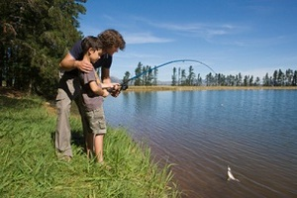 | -short clips of people talking about the river and how they interact with it  -Narrator(Anthony Stewart) starts talking about the area and saying our thesis | -Start montage of people interacting with the community and river  -Montage is approx. 30 seconds long  -Images may include: people kayaking, fishing, camping, touring French Azilum, touring Priestley house
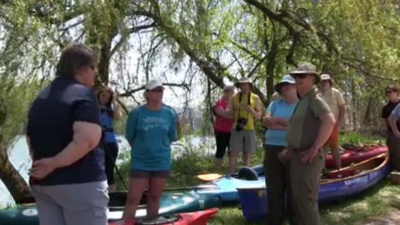 |  | -dissolve
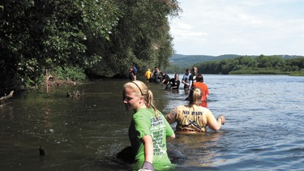 | -fade out narration, background people talking, and music  -Dave Buck says the poignant statement that connects to the past | -end montage  -Possible last image include: slow kayaking, river scene, etc. Tranquil and calm.
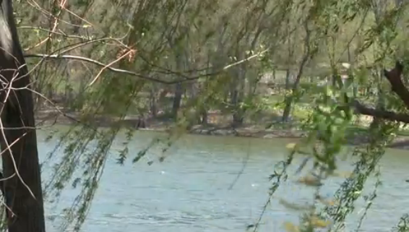 | -fade in nature sounds (river, birds, etc.) | -title fades in  -possible tilt up from same image in 5
 |  | -title fades out
- 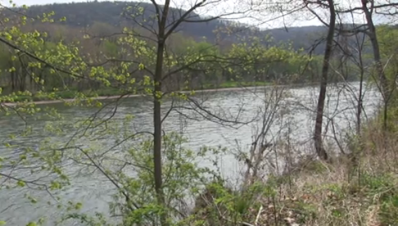 | -Narrator(Carmen) reads poem “Answer to a Child’s Question” | -dissolve  -aerial shots, drone, go-pro, tracking, pan.  -bird images, moving water  -no people
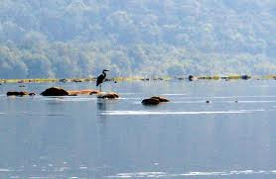 |  | -dissolve
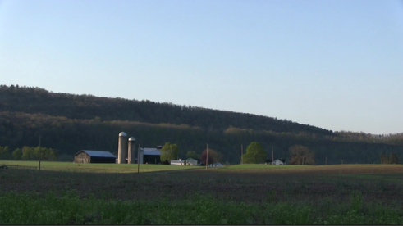 | -Narrator(Carmen) finishes reading the poem in this shot | -dissolve  -time-lapse of sunrise
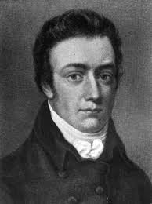 | -Narrator(Anthony) transitions to talking about Coleridge, his idea of pantisocracy, and utopias formed on the Susquehanna  -““the idea of “pantisocracy” Coleridge mentions in his poetry was inspired by a utopian vision expressed by…”  -music | -Cut  -Kens burns effect for picture?
- 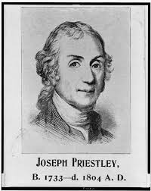 | -“..Joseph Priestley in the late 18th and early 19th centuries, which he attempted to realize…” | -Dissolve  -Another effect
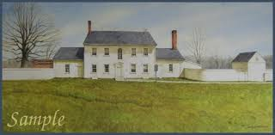 | -“… here on the banks of the Susquehanna River in Pennsylvania. In addition to the Priestley’s settlements, other potential utopias were set up along the Susquehanna, including…” | -dissolve
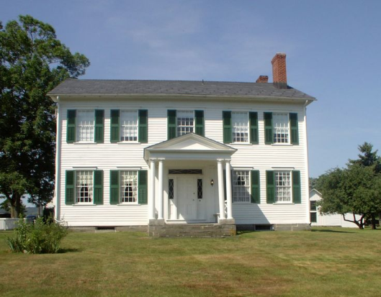 | -“…French Azilum. This settlement was founded by French Aristocrats.” | -dissolve
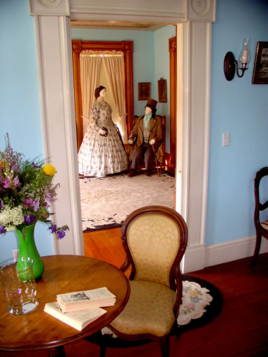 | -Narrator gives brief introduction to who the aristocrats were, i.e. loyalists from this time period, maybe name a few of the families | -dissolve  -ECU of their things, i.e. the lace crimper, the tea pots, etc.  -descendent holding on of these object(ECU)
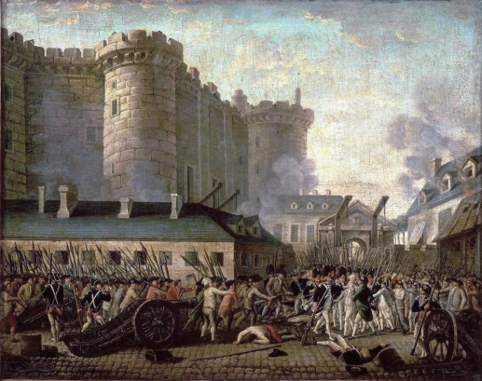 | -Narrator gives brief overview of French Revolution and how the Aristocrats and Priestley became “refugees” | -dissolve  - Possible reenactments or filmed shots of things from the time i.e. guns going off, guillotines, ballroom dancing, Priestley’s house burning
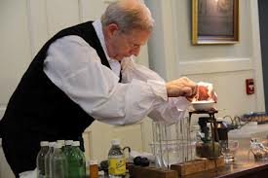 | -Narrator gives brief overview of who Priestley is, including religious beliefs and scientific background | -dissolve  -Possible reenactments from the house, ECU of his scientific equipment, Bible, etc.
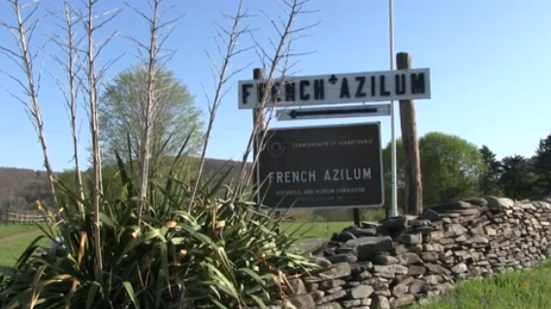 | -Narrator segues back to the Susquehanna, explains in detail French Azilum, talks about what was built(Marie Antoinette’s house, dance house), who arrived fist, who came later, the ideal plans for what was to happen  -Interview with expert(Danielle) (Homets) interspersed | -cut  -Pan shots of the land  -wide shots of area  -Shots inside the house  -Shots of interview  -drone shots
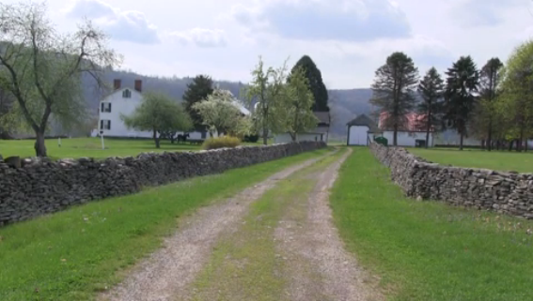 |  | -dissolve
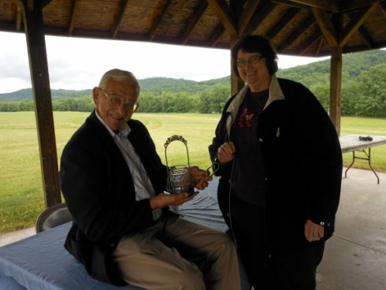 | -end narration | -dissolve  -this image is just representative of the interviewee
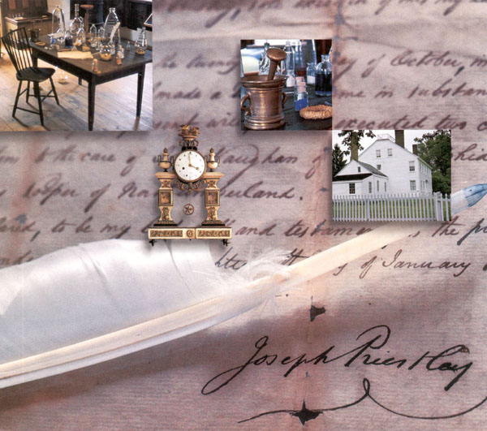 | -Narrator talks about Joseph Priestley and the “Colony of Friends”, ideals behind the community, who came with Priestley, when did more people come, etc.  -Interview with expert(Tom)(other tour guides from the house) | -cut  -Possible images include: house, reenactments, chemistry equipment  -pan shots of area  -drone shots  -shots of interview  -ECU of chemistry equipment, other objects from the house  -possible maps that Courtney is doing
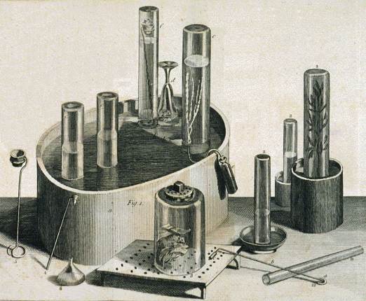 |  | -dissolve
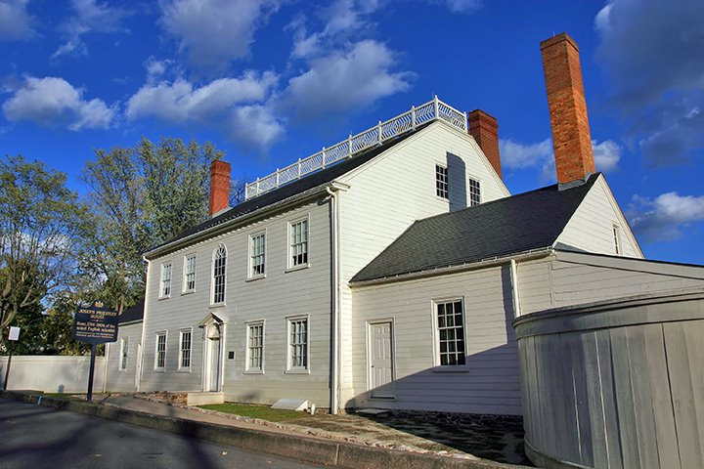 | -end narration | -dissolve
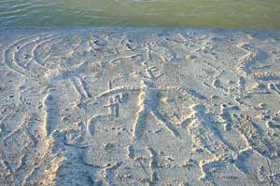 | -Narrator segues into the realities and failures of the two utopias, including Native American Removal, reality of living on the land(story of postman calling about Napoleon’s pardon), intrinsic vs. value(Priestley), people returning to Europe  -Interviews (native American leader?) (experts again) | -cut  -Possible images include: petroglyphs, houses again, pans, boats?, abandoned land  -pan shots  -ECU of trunks(closing) or people walking to represent leaving  -possible reenactments(people standing there and slowly disappearing)  -standing stone image
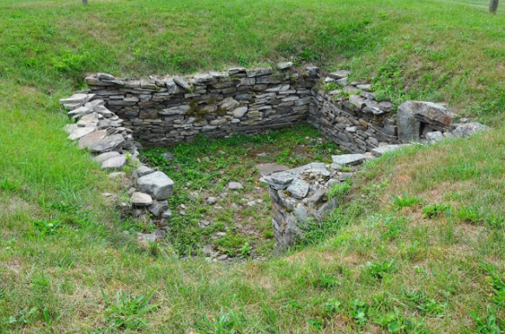 |  | -dissolve
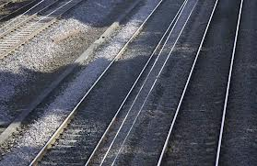 |  | -dissolve
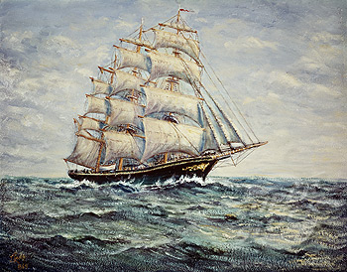 |  | -dissolve
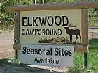 | -Narration about contemporary state of the region/landscape  -Conservation movements  -Sojourns  -Elkwood and Fracking | -dissolve
 |  | -dissolve
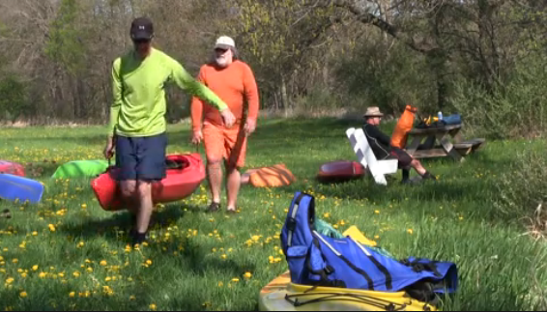 | -Narration concluding that the societies failed to be utopias, but left ideals behind and impacted the communities today  -Interspersed with people talking about the river and community again | -cut
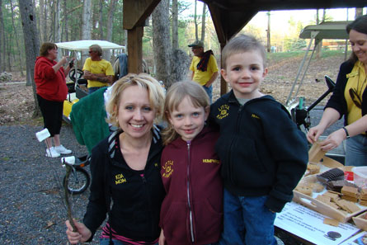 | -end people talking | -dissolve
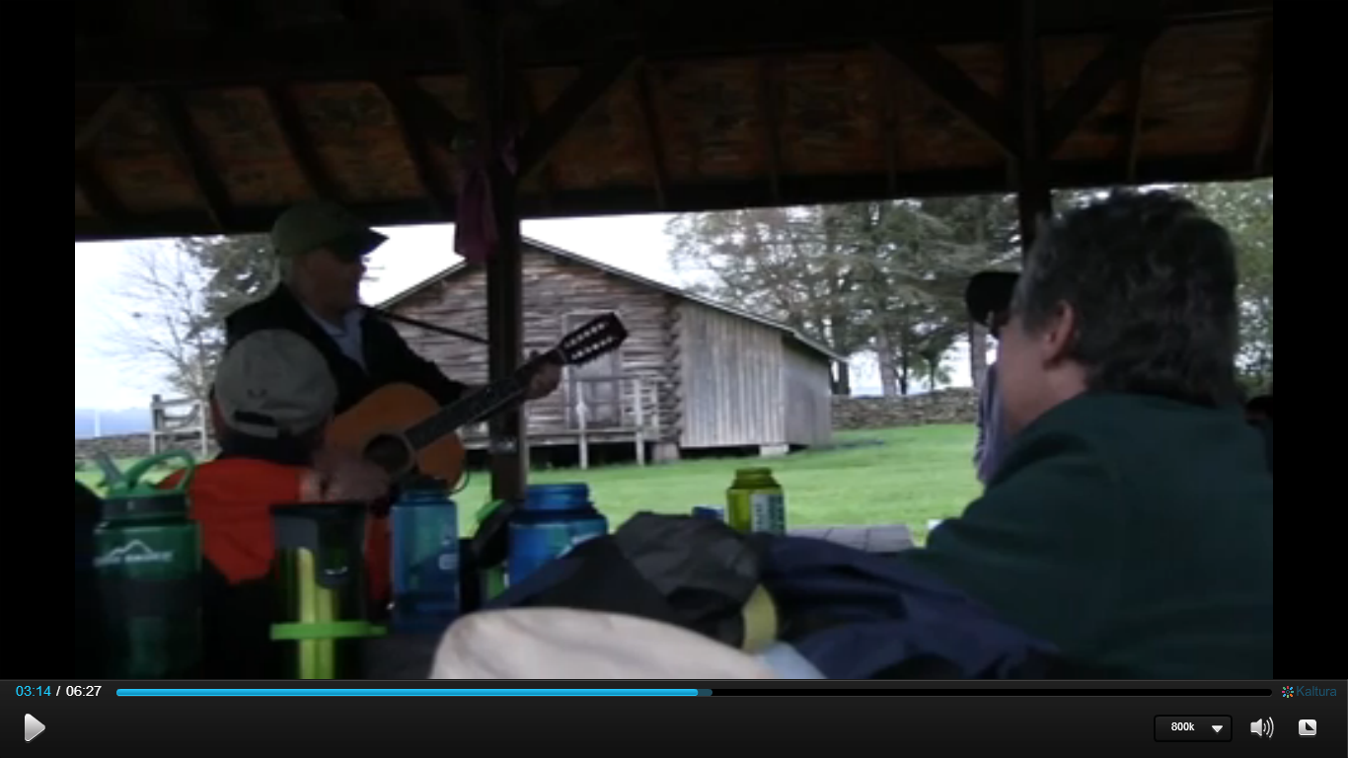 | -Closing statement from Narrator  -Fade in nature sounds  -Fade in local songwriter(Don) singing about the river | -dissolve  -CU of guitar, strumming fingers, people shaking the maracas.
 |  | -fade to black
Words  Thank you  blah |  | -Fade up credits
 | -fade out music | -fade to black, 5 seconds

****Need to do more with the Priestley house/Elkland campsite to get more concrete ideas on images****

