Image | Narration/audio | Description of Shots
 |  | -5 seconds
 | -Fade in low music  -Fade in people talking | -1 second
- 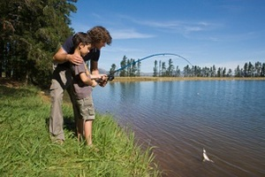 | -short clips of people talking about the river and how they interact with it  -Narrator(Anthony Stewart) starts talking about the area and saying our thesis | -Start montage of people interacting with the community and river  -Montage is approx. 30 seconds long  -Images may include: people kayaking, fishing, camping, touring French Azilum, touring Priestley house
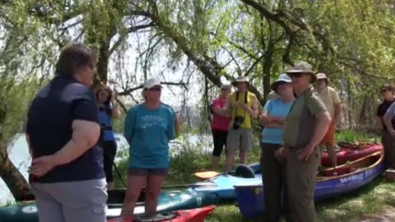 |  | -dissolve
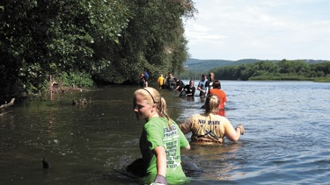 | -fade out narration, background people talking, and music  -Dave Buck says the poignant statement that connects to the past | -end montage  -Possible last image include: slow kayaking, river scene, etc. Tranquil and calm.
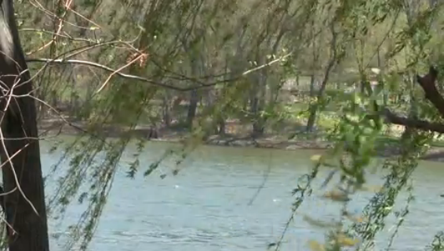 | -fade in nature sounds (river, birds, etc.) | -title fades in  -possible tilt up from same image in 5
 |  | -title fades out
- 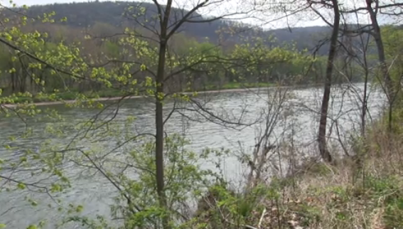 | -Narrator(Carmen) reads poem “Answer to a Child’s Question” | -dissolve  -aerial shots, drone, go-pro, tracking, pan.  -bird images, moving water  -no people
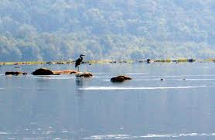 |  | -dissolve
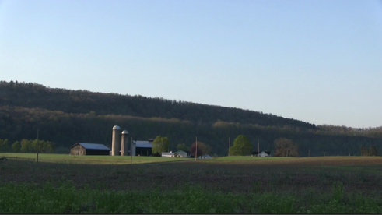 | -Narrator(Carmen) finishes reading the poem in this shot | -dissolve  -time-lapse of sunrise
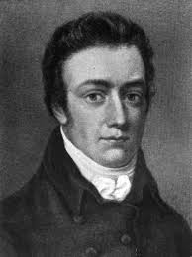 | -Narrator(Anthony) transitions to talking about Coleridge, his idea of pantisocracy, and utopias formed on the Susquehanna  -music | -Cut  -Kens burns effect for picture?
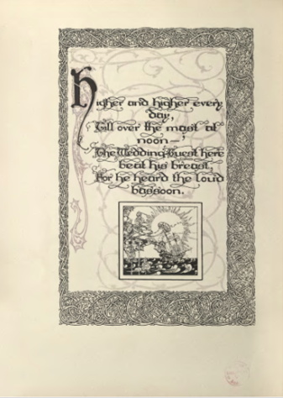 | -““the idea of “pantisocracy” Coleridge mentions in his poetry was inspired by a utopian vision expressed by…” | -Dissolve  -Possible image includes: someone writing out a poem, an old manuscript, etc.
- 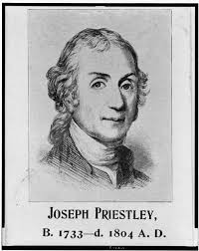 | -“..Joseph Priestley in the late 18th and early 19th centuries, which he attempted to realize…” | -Dissolve  -Another effect
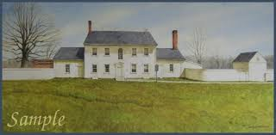 | -“… here on the banks of the Susquehanna River in Pennsylvania. In addition to the Priestley’s settlements, other potential utopias were set up along the Susquehanna, including…” | -dissolve  -Possible images include: pans of the house, aerial shots of it, map of the landholdings  -*LA shots preferred to give the appearance of grandeur, to contrast humbled appearance later
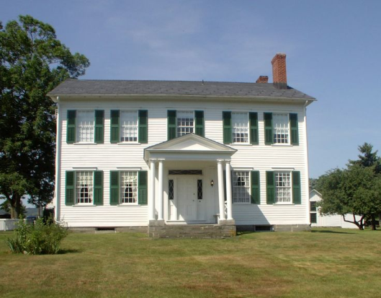 | -“…French Azilum. This settlement was founded by French Aristocrats.” | -dissolve  -Possible images include: pans of the house, aerial shots of it, map of the landholdings  -*LA shots preferred to give the appearance of grandeur, to contrast humbled appearance later
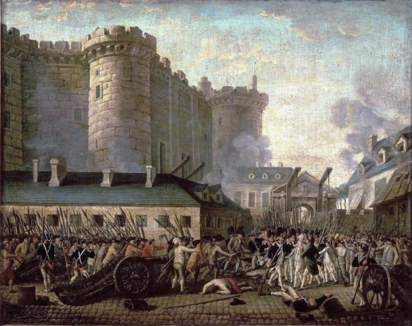 | -Narrator gives brief overview of French Revolution | -dissolve  - Possible reenactments or filmed shots of things from the time i.e. guns going off, guillotines, boots stomping,
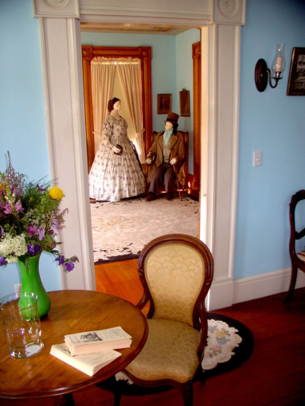 | -Narrator gives brief introduction to who the aristocrats were, i.e. loyalists from this time period, maybe name a few of the families | -dissolve  -ECU of their things, i.e. the lace crimper, the tea pots, etc.  -descendent holding on of these object(ECU)
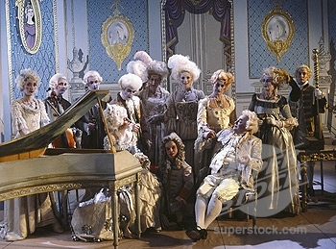 | -Narrator talks about how the aristocrats became “refugees” | -dissolve  -Possible reenactments, ballroom dancing and guillotines, shouting
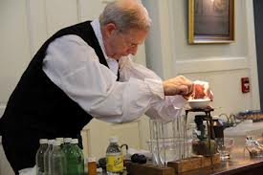 | -Narrator gives brief overview of who Priestley is, including religious beliefs, dissenter, and scientific background | -dissolve  -Possible reenactments from the house, ECU of his scientific equipment, Bible, etc.
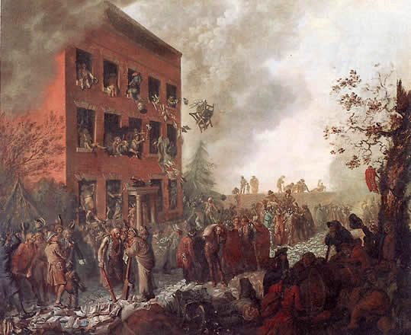 | -Narrator talks about how Priestley became a “refugee” | -dissolve  -Possible reenactments,  Priestley’s house burning, close up of fire, running, shouting
 | -Ocean/port sounds, no narration, insinuating leaving France | -Dissolve
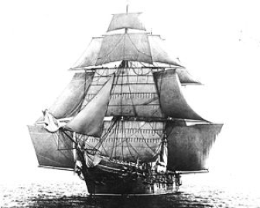 |  | -overlay
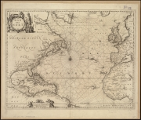 | -transition, ocean sounds fading out, nature sounds fading in | -overlay
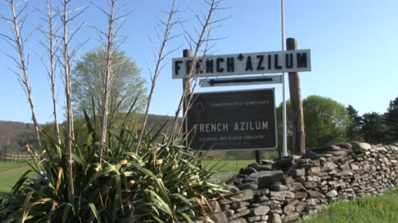 | -Narrator explains in detail French Azilum, talks about what was built | -cut  -Pan shots of the land  -wide shots of area  -Shots inside the house  -Shots of interview  -drone shots
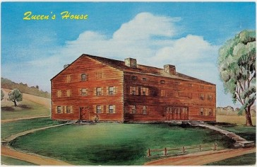 | -Marie Antoinette’s house | -Possible images include: drawing of her house, dress swoshing, reenactment in front of a vanity, ECU white curls, parasol, gloves?, powder,
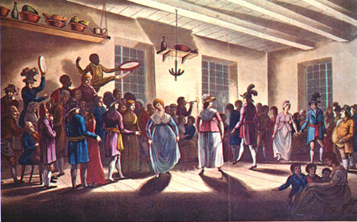 | -dance house | -Possible images: dancing feet, hands: touching to dance, playing instruments, etc.
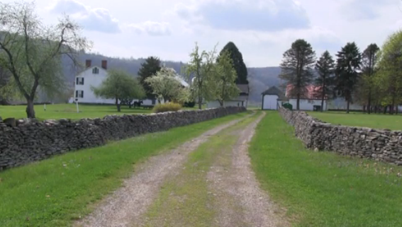 | -who arrived fist, who came later, the ideal plans for what was to happen  -Interview with expert(Danielle) (Homets) interspersed | -dissolve
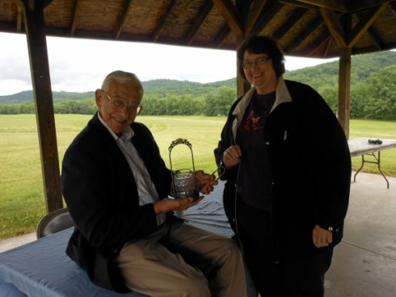 | -end narration | -dissolve  -this image is just representative of the interviewee
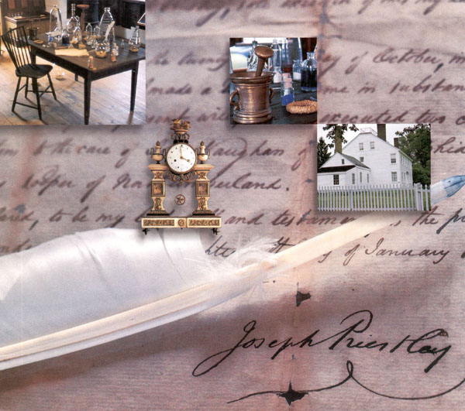 | -Narrator talks about Joseph Priestley and the “Colony of Friends”  -who came with Priestley, etc. | -cut  -Possible images include: house, reenactments, chemistry equipment  -pan shots of area  -drone shots  -shots of interview  -ECU of chemistry equipment, other objects from the house  -possible maps that Courtney is doing
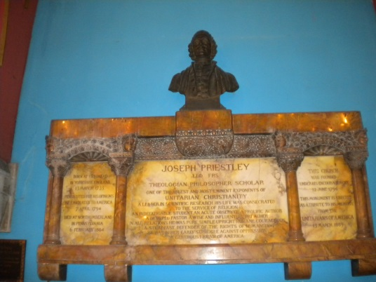 | -ideals behind the community,  -interview with minister, progress ideal* | -dissolve  -Possible images: ECU Bible, tracking shot along pews?, altar?, nature
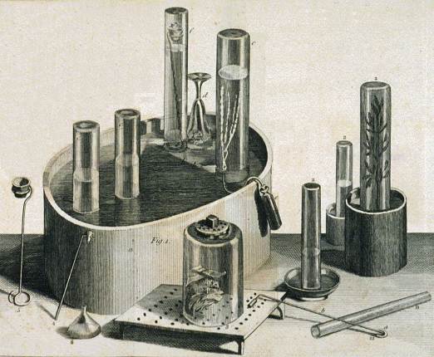 | -Scientific studies done here | -dissolve  -Possible images include: lab, ECU of equipment, possible reenactment of experiments
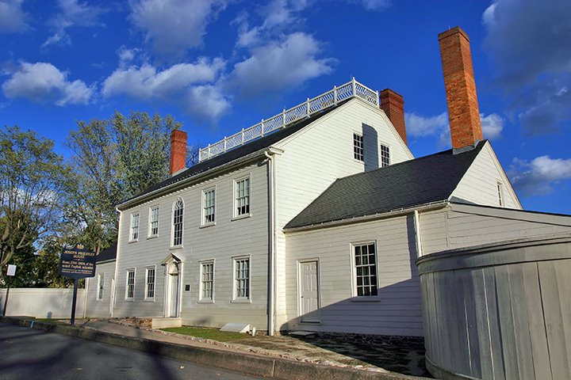 | -Interview with expert(Tom)(other tour guides from the house) interspersed  -end narration | -dissolve
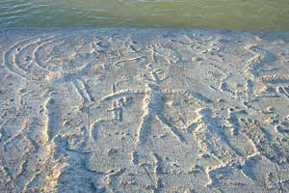 | -Narrator segues into the realities and failures of the two utopias, including Native American Removal),  -Interviews (native American leader?) | -cut  -Possible images include: petroglyphs,  shots  -standing stone image
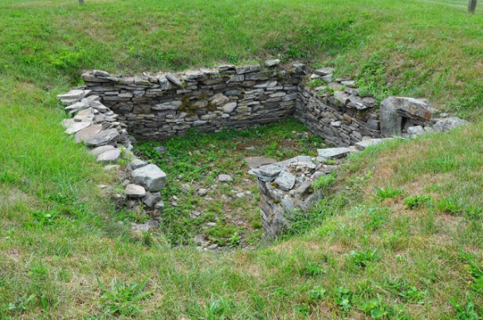 | -reality of living on the land(story of postman calling about Napoleon’s pardon), | -dissolve  -Possible images include: Napoleon, houses again, pans, boats?, abandoned land
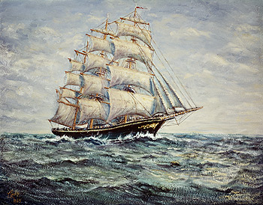 | -people returning to Europe | -dissolve  -ECU of trunks(closing) or people walking, walking over a doorway threshold to represent leaving  -possible reenactments(people standing there and slowly disappearing)
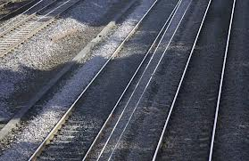 | -intrinsic vs. value (Priestley and progress) | -dissolve  -Possible images: railway, tombstone, empty room in the house, silhouette
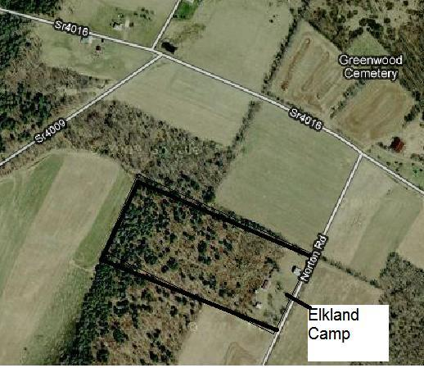 | -Narration about contemporary state of the region/landscape  -Elkland | -dissolve into an aerial shot of the area
 | -Conservation movements  -Interviews(Phil) (Dave Buck) | -dissolve
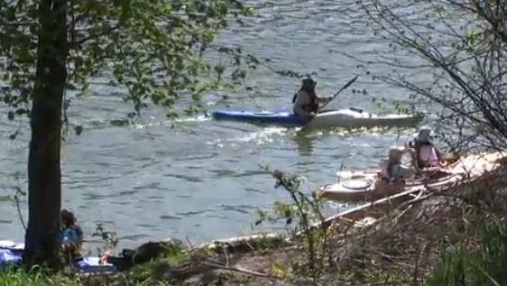 | -Sojourns | -dissolve
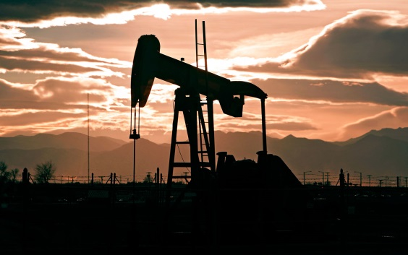 | -Fracking | -dissolve
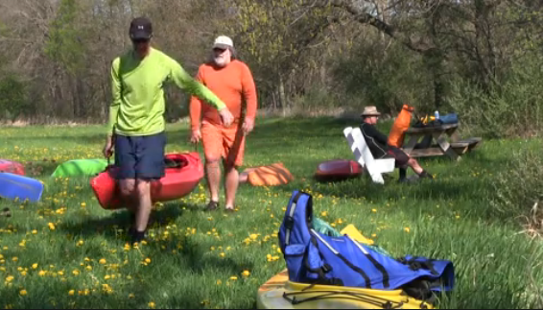 | -Narration or interview concluding that the societies failed to be utopias, but left ideals behind and impacted the communities today  -Interspersed with people talking about the river and community again | -cut
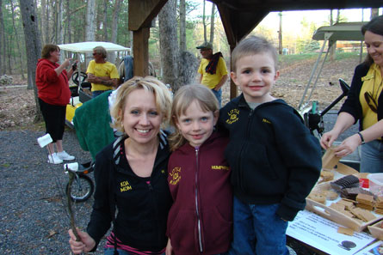 | -end people talking | -dissolve
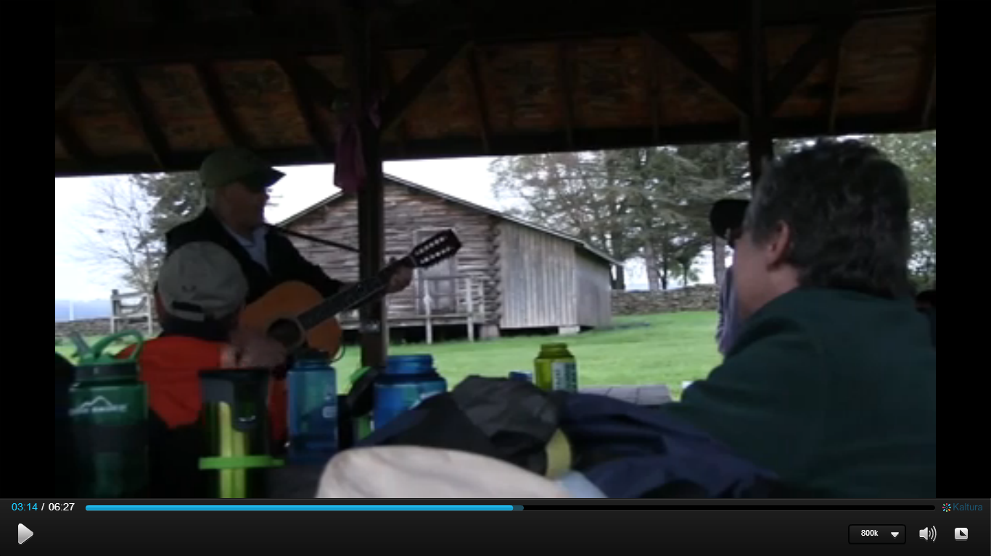 | -Closing statement from Narrator  -Fade in nature sounds  -Fade in local songwriter(Don) singing about the river | -dissolve  -CU of guitar, strumming fingers, people shaking the maracas.
 |  | -fade to black
Words  Thank you  blah |  | -Fade up credits
 | -fade out music | -fade to black, 5 seconds

****Need to do more with the Priestley house/Elkland campsite to get more concrete ideas on images****

